SWITCHING AND VLANS

Q1. Draw a simple network diagram showing three devices (like your laptop, a friend's phone, and a smart TV) connected to a switch, and label which device is in which VLAN (e.g., VLAN 10 for streaming, VLAN 20 for personal devices).
Ans.
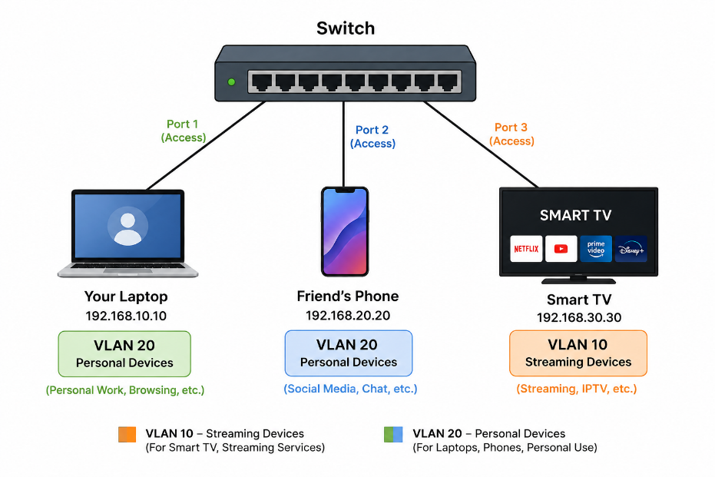
Q2. Configure a simulated switch using Cisco Packet Tracer or NETSIM: create two VLANs (VLAN 10 and VLAN 20), assign three PCs to VLAN 10 and two PCs to VLAN 20, and verify that PCs in different VLANs cannot ping each other. Hint:</strong> Use the 'VLAN' and 'switchport access VLAN' commands in the simulator CLI.
Ans. VLAN Configuration — Short Answer
- Step 1: Create VLANs
- VLAN 10
- VLAN 20
- Step 2: Assign 3 PCs to VLAN 10
- interface range fa0/1-3
- switchport mode access
- switchport access VLAN 10
- Step 3: Assign 2 PCs to VLAN 20
- interface range fa0/4-5
- switchport mode access
- switchport access VLAN 20
- Step 4: Verify
- show VLAN brief

- Step 5: Ping test
- Same VLAN → Ping works
- Different VLAN → Ping fails
- Reason: Different VLANs are separate networks and need a router/Layer-3 switch to communicate.
Q3. In any network simulator, set up a scenario where you move a PC from VLAN 10 to VLAN 20. Show the before and after configuration commands and test connectivity to confirm the change.
Ans. Moving a PC from VLAN 10 to VLAN 20. Assume PC1 is connected to Fa0/1.
- Step 1: Before — PC is in VLAN 10
- enable
- configure terminal
- interface fa0/1
- switchport mode access
- switchport access VLAN 10
- Test:
- PC1 → PC2 (VLAN 10): Ping successful
- PC1 → PC3 (VLAN 20): Ping fails
- Step 2: Move PC1 to VLAN 20
- interface fa0/1
- switchport access VLAN 20
- Step 3: Verify
- show VLAN brief
- PC1 should now appear under VLAN 20.
- Step 4: Test again
- PC1 → PC2 (VLAN 10): Ping fails
- PC1 → PC3 (VLAN 20): Ping successful

Q4. Write a short script or command list that would automate assigning 10 ports on a switch to VLAN 30, using the syntax of your chosen simulator (Packet Tracer, Net Sim, or GNS3). Constraint: Use a loop or range command if supported by the tool to avoid repeating the same command 10 times.
Ans. Cisco Packet Tracer — Assign 10 Ports to VLAN 30
enable
configure terminal
VALN 30
exit

interface range fa0/1-10
switchport mode access
switchport access VLAN 30
exit
Verification:
show VLAN brief
- This uses interface range fa0/1-10 to assign 10 ports at once, avoiding repeated commands.

